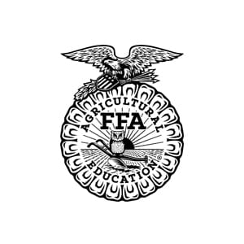
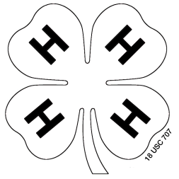
2021 Vinton County Junior Fair
Livestock Dates and Rules

February 12 Turkey Orders Due (Extension Office or Mail)

March 30 Chicken Orders Due (Extension Office or Mail)

April 14 Quality Assurance (5 PM via Zoom)
April 20 Quality Assurance (6 PM via Zoom)

May 8 Spring Tag-in (9 AM-NOON Fairgrounds)
* goats, sheep, hogs, dairy feeders
May 26 Quality Assurance (6 PM Fairgrounds)

June 1 Horse ID Forms Due
Breeding Animal Forms Due (includes feeder calves and pack goats)

July 1 Rabbit Tattooing (5-7 PM Fairgrounds)
July 13-14 4-H Project Judging TBD
July 26-31 Vinton County Junior Fair

December 11 Steer Weigh-In (11 AM-NOON Fairgrounds)

This information is complete to the best of our knowledge at the time of printing. We strongly recommend that you read all email updates which are sent out of a regular basis. You can read past updates at www.vinton.osu.edu or our Facebook page for all up-to-date information. You can always contact our office at 740-596-5212 or email west.222@osu.edu

Livestock Rules can be downloaded from vinton.osu.edu or vintoncountyjrfair.com

